IOT PHASE-3

SMART FOUNTAIN SYSTEM

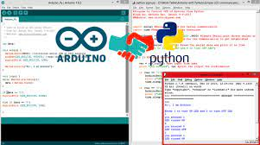

# **Introduction:**

In the realm of modern urban infrastructure, the fusion of technology and sustainability has ushered in a wave of innovative projects poised to revolutionize our relationship with the environment. Among these pioneering initiatives is the "Smart Water Fountain" project, a visionary undertaking that leverages the power of the Internet of Things (IoT) and Python scripting.

At its essence, this project confronts pressing concerns related to resource efficiency, real-time monitoring, malfunction detection, and fostering heightened awareness among urban residents. Through the strategic deployment of IoT devices and the development of Python scripts, this endeavor holds the promise of delivering tangible benefits to both city inhabitants and the natural world.

In the course of this project, a Python script has been meticulously crafted to serve as the crucial conduit between the physical and digital domains. Establishing a seamless serial connection with Arduino-based IoT devices, this script stands as the linchpin of our efforts, acting as the alchemist that transmutes raw data into actionable insights. It is this Python script that forms the heartbeat of our initiative, entrusted with the vital role of translating data into informed actions, all in the pursuit of our project's overarching objectives.



# **Python Script:**

import serial

import time

# Define the serial port and baud rate (adjust as needed)

ser = serial.Serial('COM3', 9600) # Replace 'COM3' with the correct serial port for your Arduino

try:

while True:

# Read data from the Arduino

data = ser.readline().decode('utf-8').strip()

# Process the data (you can customize this part)

if data:

# Split the data into values (assuming CSV format, adjust as needed)

values = data.split(',')

# Check if the data is valid and has the expected number of values

if len(values) == 4:

flow_rate, pressure, temperature, water_quality = map(float, values)

# Process and use the sensor data as needed

print(f"Flow Rate: {flow_rate} L/min")

print(f"Pressure: {pressure} PSI")

print(f"Temperature: {temperature} °C")

print(f"Water Quality: {water_quality}")

else:

print("Invalid data received")

# Add a delay if needed to control the data polling rate

time.sleep(1)

except KeyboardInterrupt:

print("Script terminated by the user.")

finally:

ser.close() # Close the serial connection when done

-----------------------------------------------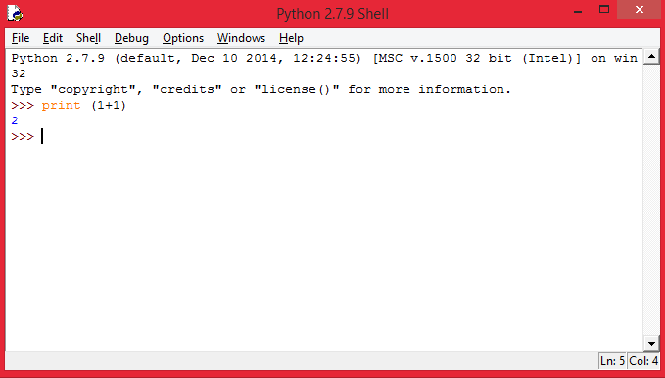-----------------------------------------------------------------------------------

# **Conclusion:**

In conclusion, the Python script developed for the "Smart Water Fountain" project represents the vital link in our mission to create intelligent, sustainable, and user-centric urban infrastructure. As sensor data flows from the Arduino devices to our Python script, it undergoes transformation into actionable information, contributing to real-time monitoring, efficient water usage, malfunction detection, and resident awareness.

By integrating technology and sustainability, we have taken a step towards reshaping urban living. The "Smart Water Fountain" project is not just about delivering clean, accessible water; it's about fostering a sense of responsibility, promoting efficient resource management, and empowering city dwellers with real-time information